 VINOD SIR’S GROUP TUTION

MARKS:40 IX-HISTORY TIME: 1 Hr. 30 Mins.

Q. 1: Fill in the blanks for the following: [2]

1. ................. was named as the first Chairman of atomic energy commission.
2. ................. was the first completely indigenous communication satellite made by ISRO.

Q. 2: Identify the wrong pair. [1]

(1) Prithvi - Surface to surface ballistic missile
(2) Agni Surface to underwater ballistic missile
(3) Akash From surface to air attacking missile
(4) Nag Anti-tank missile

Q. 3: Explain the following concepts. [4]

(1) Space research (2) Telex service

Q. 4: Explain the following with reasons. (Any 2) [4]

1. Pandit Nehru established the Atomic Energy Commission.
2. India decided to conduct nuclear tests.
3. USA imposed economic sanctions on India.

Q. 5: Write the answers in 25 to 30 words [4]

1. Write about Pokhran nuclear test.
2. For which sector was Bhaskar – 1 satellite expected to be useful?

Q. 6 :Write the answer in brief for the following: (Any 3) [6]

1. Which of the everyday services are influenced by the satellite technology ?
2. Why is Dr. A.P.J. Abdul Kalam called as the ‘Missile Man’?
3. How one can do computerized reservation for rail travel ?
4. Write the key features of Konkan Railway.
CIVICS

Q. 1: Explain with reasons whether the following statements are true or false.
(Any 2) {4}

1. India has an important position among the South Asian countries.
2. Sino-Indian relations are friendly.
3. India sent a peacekeeping force to help the Sri Lankan government.

Q. 2: Complete the following chart. (Any3) [3]

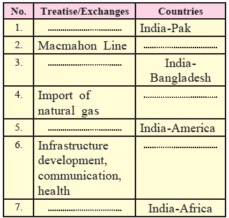

Q 3: Write the shorte for the following: (Any 2) [4]

1. Shimla Agreement 2. Indo-Nepalese friendship treaty
3. Machmahon Line 4. Indo-Afghanistan Relations

Q 4: Answer the following questions in brief. (Any 2) [4]

1. Explain the background of cooperative relations between India and America
2. Give some information about the efforts taken by India for the establishment of democracy in neighbouring countries with examples.
3. What is the role of South Asian Association for Regional Cooperation ?

Q. 5: Give your own opinion about : (Any 2) [4]

1. What remedies would you suggest in order to reduce the tensions in the relations between India and Pakistan ?
2. Do you agree with the statement : ‘Hurdles are created in the way of internal development due to tense relations of India with neighbouring countries.’ Explain with reasons.
3. Do you think that strong healthy relations of India with America are conducive to India’s economic development ?

